Maven Installation:

1. Download latest maven from the Apache maven site <https://maven.apache.org/download.cgi>:

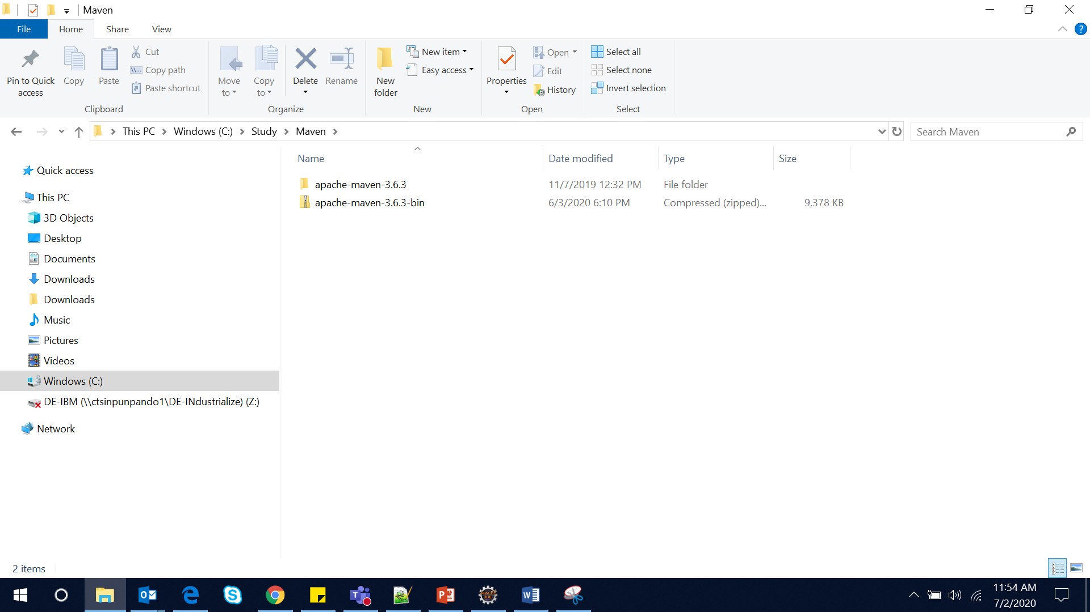

1. Add maven bin location to PATH variable:

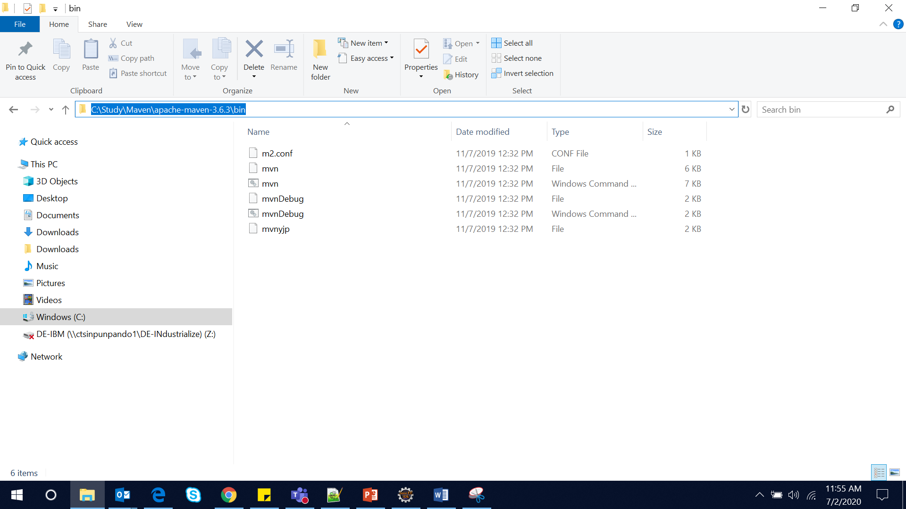

1. Update the below section with the folder to store all the dependent jar files for maven development:

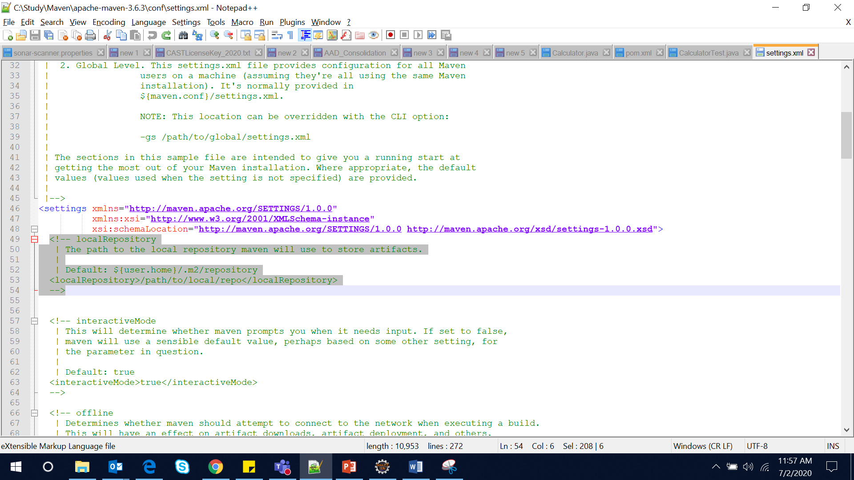

1. Add below tags to set the SonarQube server location:

